**OUTPUTS**

**Developing a Backend Admin for Learner’s Academy.**

**Flow chart:**

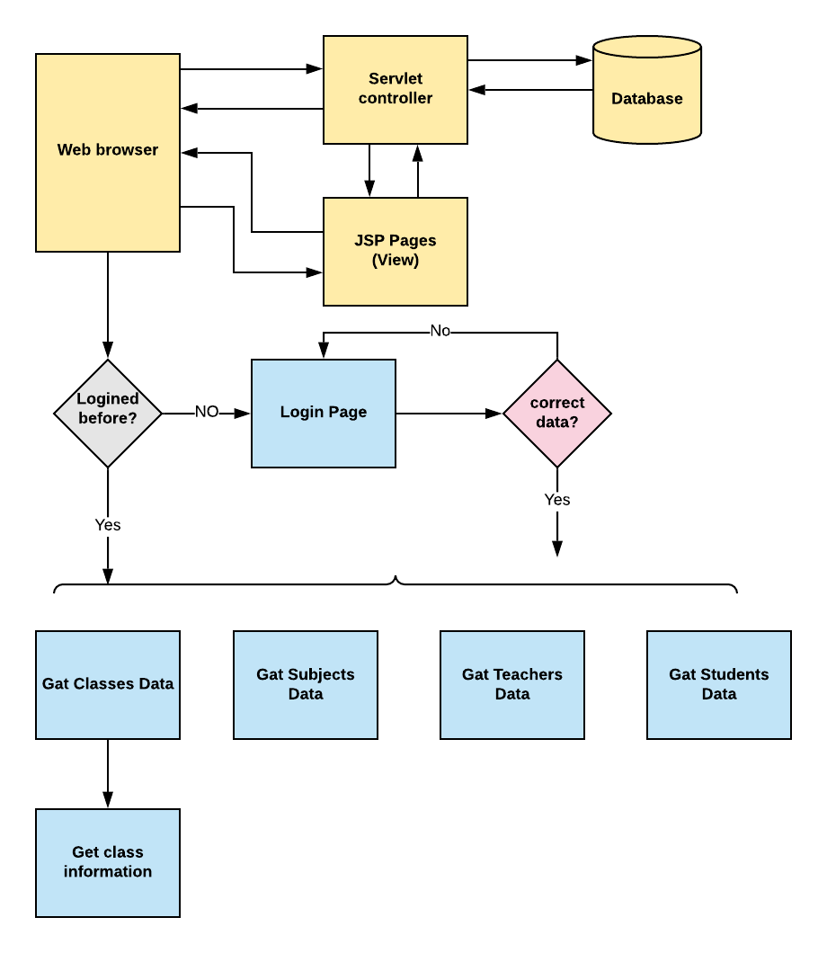

**1.Login page:**

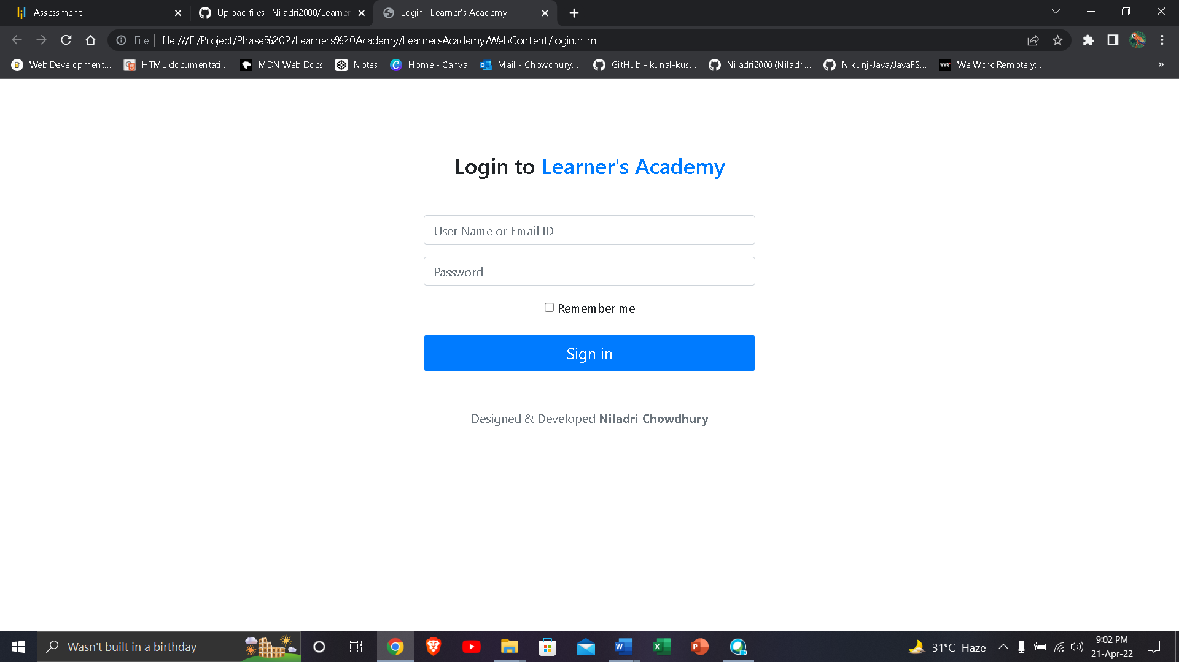

**2. Enter the username and password :**

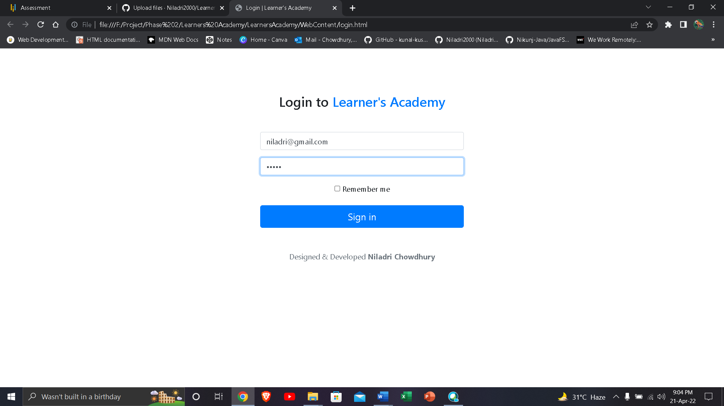

**3.Classes:**

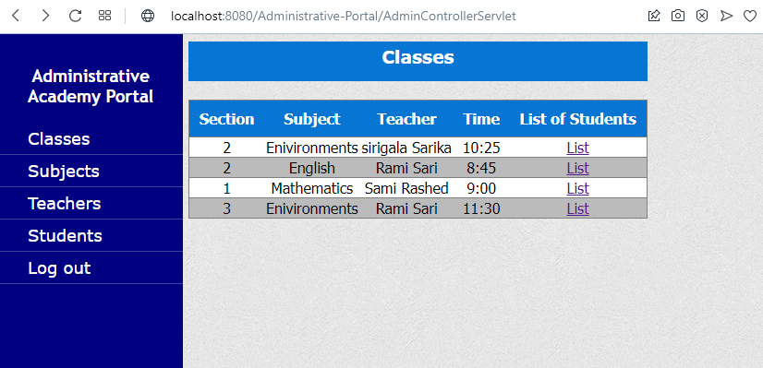

**3.1. List of students in mathematics classes section1:**

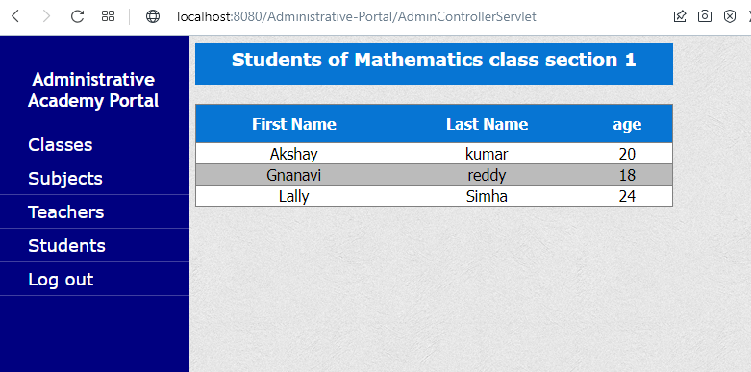

**3.2. List of students in environment classes section3:**

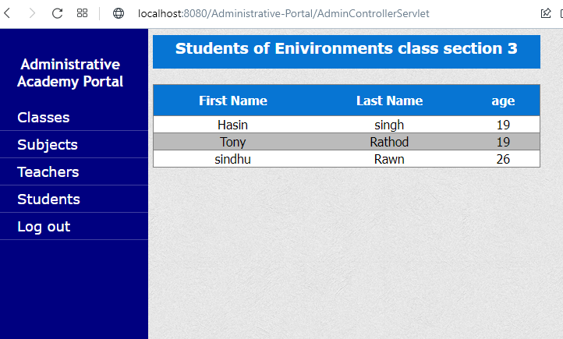

**4. Subjects:**

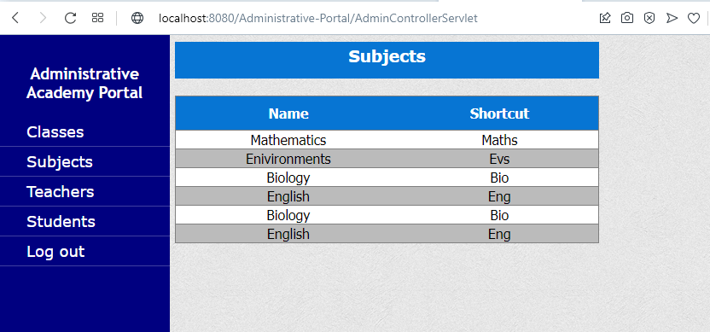

**5.Teachers:**

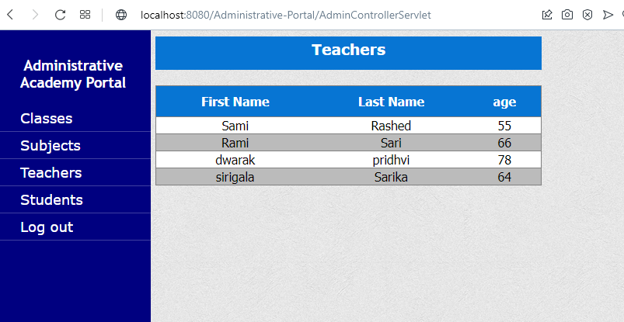

**6.Students:**

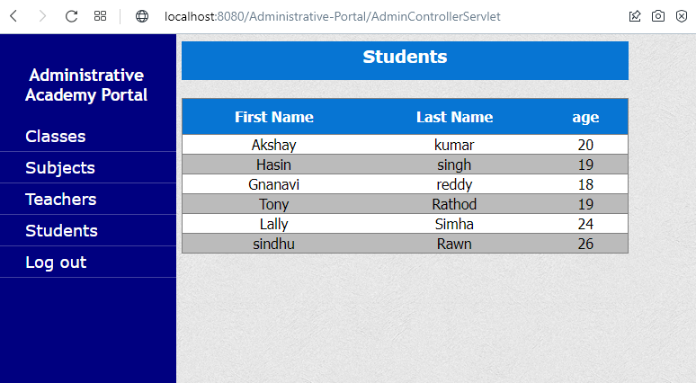

**7. Logout page:**

